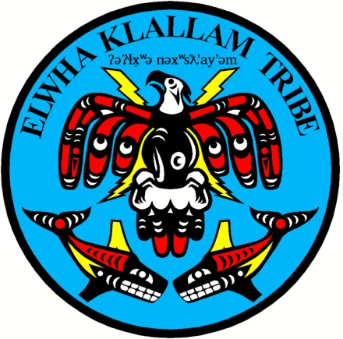
LOWER ELWHA KLALLAM TRIBE

ʔəʔɬx̣ʷə nəxʷsƛay̕əm “Strong People”

2851 Lower Elwha Road Phone: 360.452.8471
Port Angeles, WA 98363 Fax: 360.452.3428

October 20, 2023

Dear Native Network customer –

In response to the pandemic, the Tribe has been able to provide free Internet service since January 2021 to your location on the Reservation. At the end of this year, the funding for this service will run out; therefore, a new program could still allow you to receive free or reduced-priced Internet.

Our tribal telecom partner, Native Network, will continue to offer the existing internet service at your location for a monthly fee of $69.95 … AND could be entirely paid for or dramatically reduced by a national Internet program called the Affordable Connectivity Program (ACP), if you are eligible.

PLEASE FOLLOW THE ATTACHED SIGNUP FOR INTERNET SERVIVE WITH AFFORDABLE CONNECTIVITY PROGRAM (ACP) INSTRUCTIONS TO DETERMINE YOUR ELIGIBILITY.

Once approved, please complete and return the Signup for Internet Service form, and you will be all set! If you are not eligible and would like to continue and pay for your existing service at $69.95 per month, please also complete the form.
If you don't respond and submit a form, your service will disconnect on December 31, 2023.

If you have any questions, please call Native Network at 833-364-0594 for assistance completing the ACP application.

